Production ML systems
Introduction
example: The values of one row of features and possibly a label.
Static vs. dynamic training
Static training: only training a model once
Dynamic training: training a model continuously or frequently
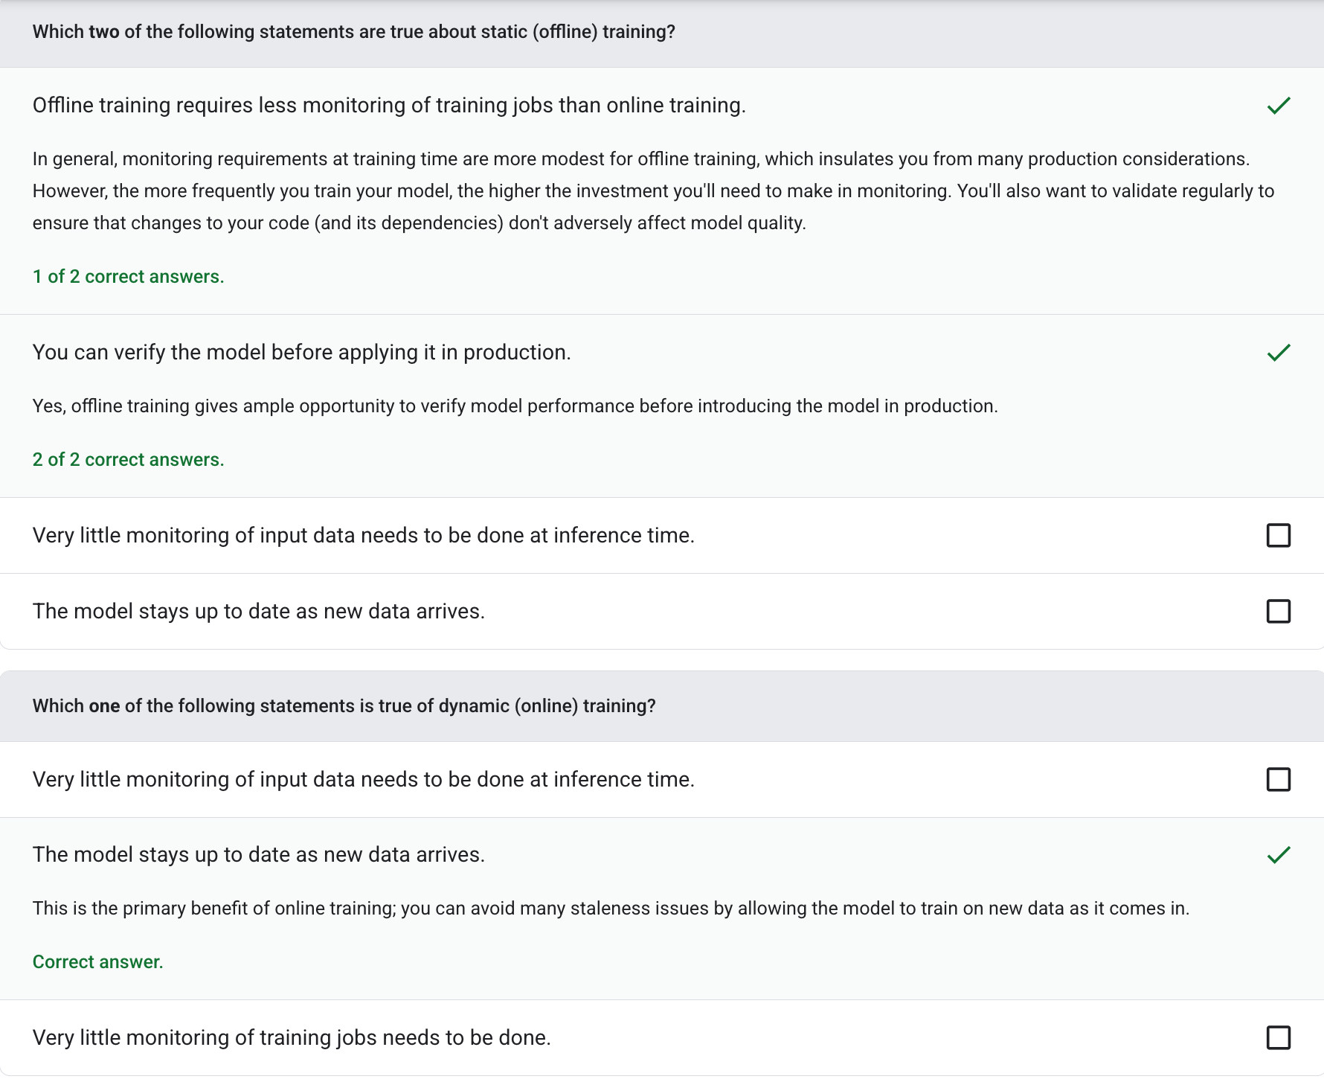
Static vs. dynamic inference
inference: In traditional machine learning, the process of making predictions by applying a trained model to unlabeled examples.
unlabeled example: An example that contains features but no label.
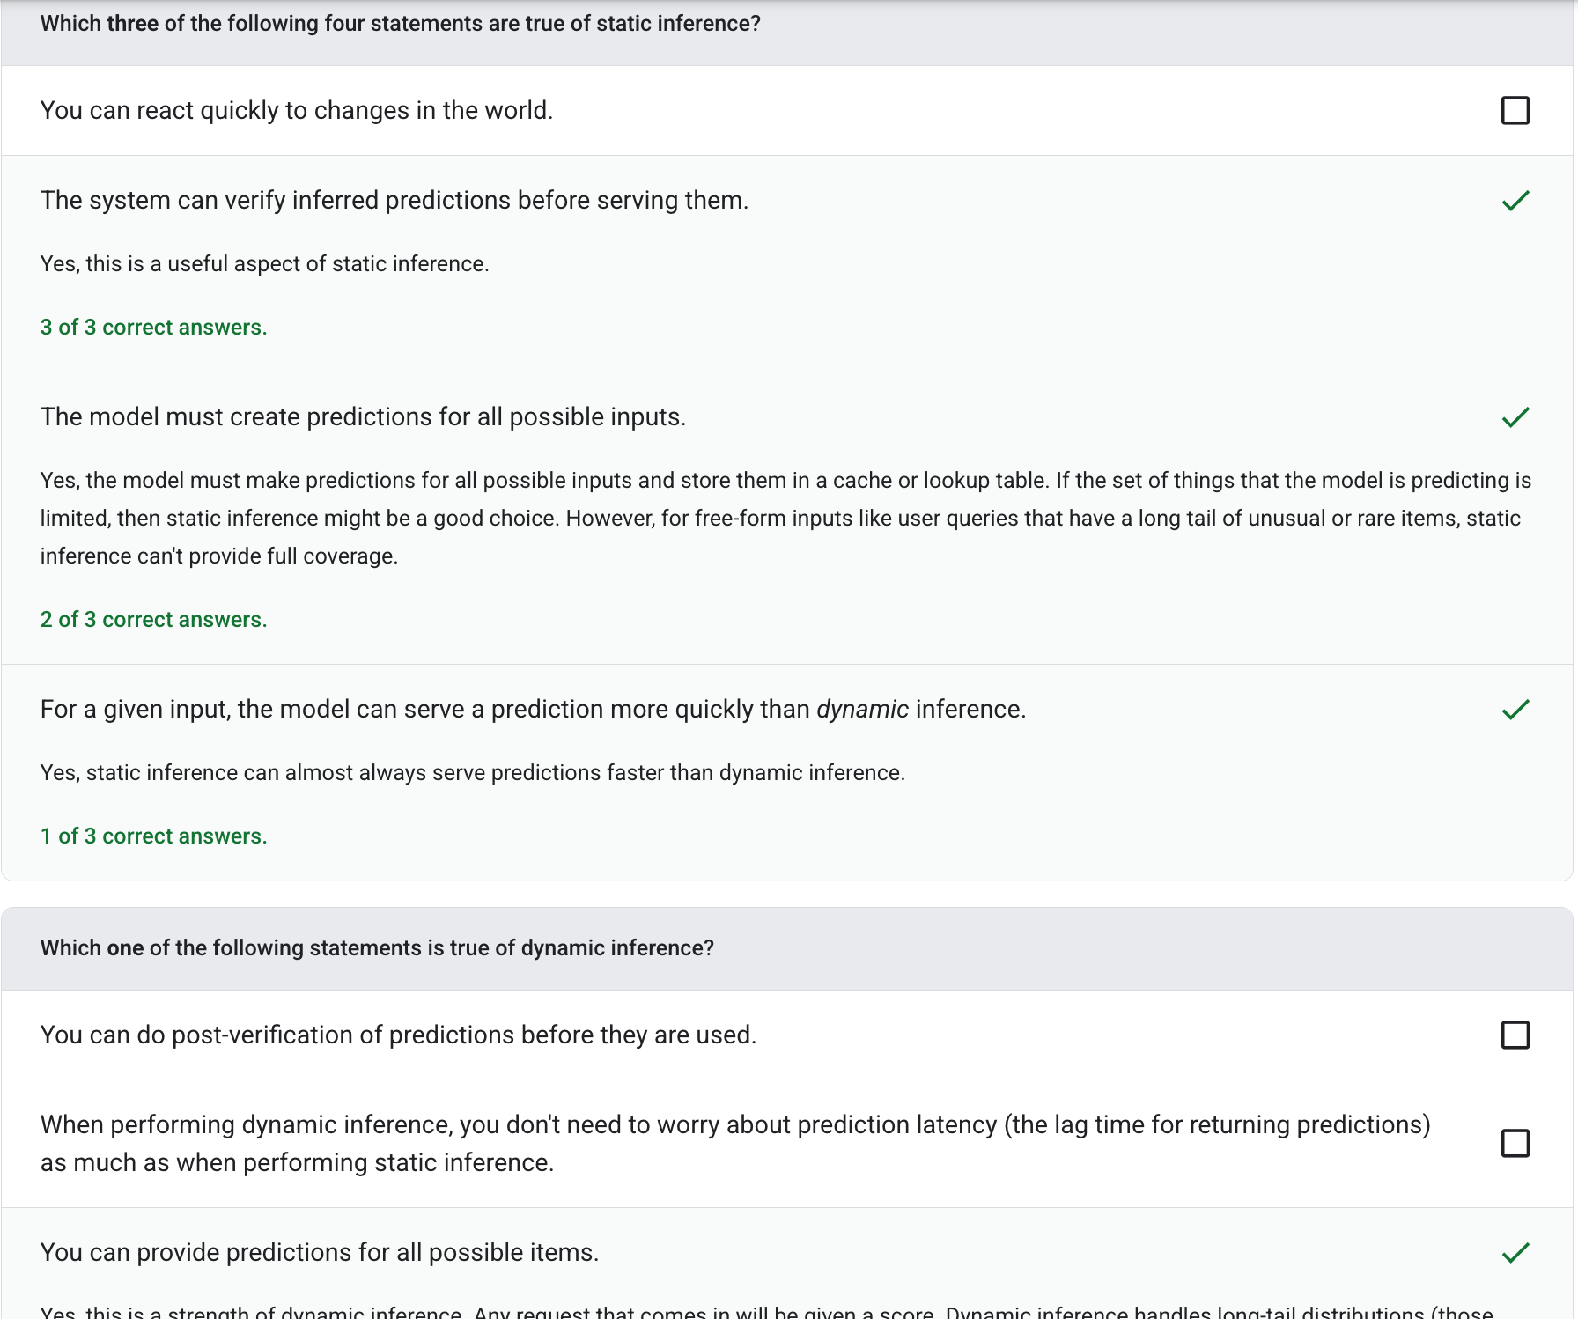
When to transform data?
training-serving skew: The difference between a model's performance during training and that same model's performance during serving.
Z-score normalization: A scaling technique that replaces a raw feature value with a floating-point value representing the number of standard deviations from that feature's mean.
Z-score normalization: A scaling technique that replaces a raw feature value with a floating-point value representing the number of standard deviations from that feature's mean.
outliers: Values distant from most other values.
clipping: A technique for handling outliers by doing either or both of the following:
• Reducing feature values that are greater than a maximum threshold down to that maximum threshold.
• Increasing feature values that are less than a minimum threshold up to that minimum threshold.
scaling: Any mathematical transform or technique that shifts the range of a label, a feature value, or both.
one-hot encoding: Representing categorical data as a vector in which:
• One element is set to 1.
• All other elements are set to 0.
Deployment testing
training-serving skew: The difference between a model's performance during training and that same model's performance during serving.
AUC (Area under the ROC curve): A number between 0.0 and 1.0 representing a binary classification model's ability to separate positive classes from negative classes.
ground truth: Reality.
Monitoring pipelines
hashing: In machine learning, a mechanism for bucketing categorical data, particularly when the number of categories is large, but the number of categories actually appearing in the dataset is comparatively small.
label leakage: A model design flaw in which a feature is a proxy for the label.
training-serving skew: The difference between a model's performance during training and that same model's performance during serving.
Questions to ask
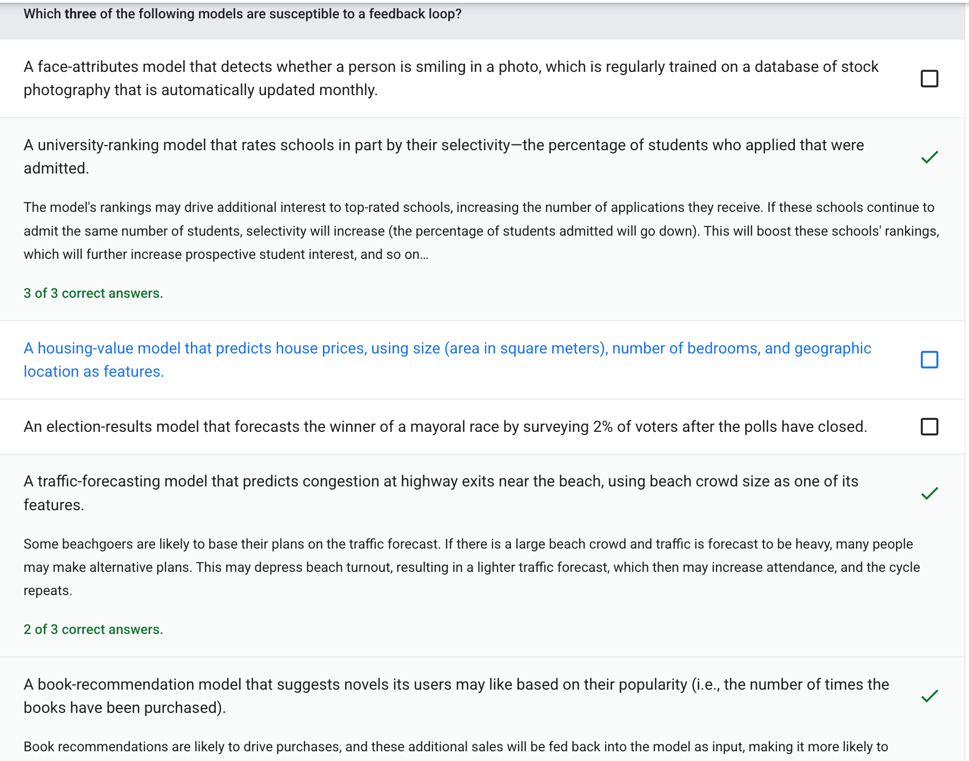
Test your knowledge


